SOMERSAULT

July 2017

Vol 40, No 4

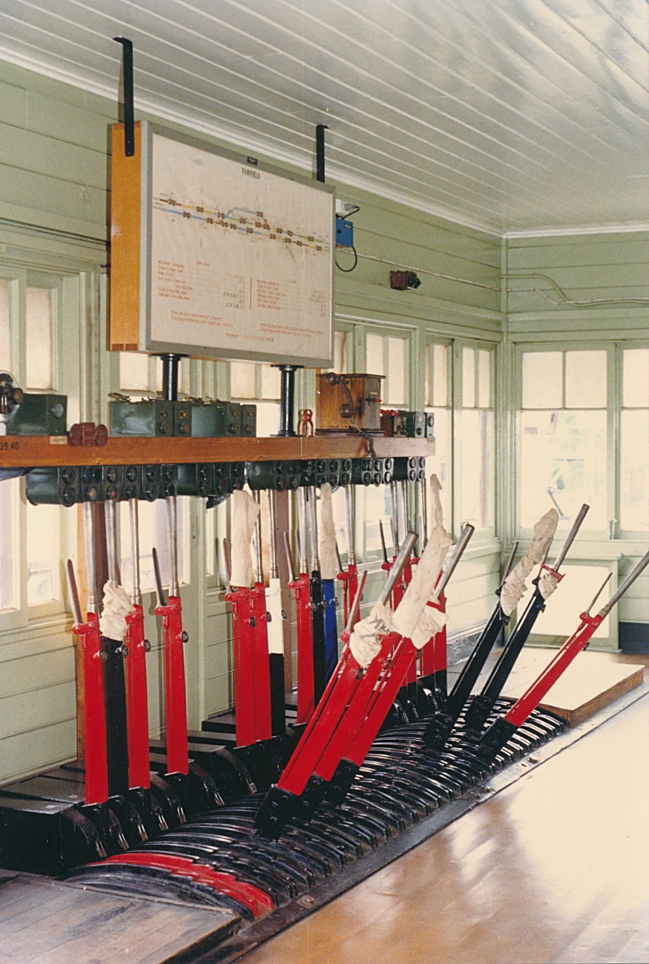Signalling Record Society of Victoria

# Society Contact Information

(Front cover). The interior of Fairfield signal box on 21 October 1987 – just under 30 years ago – was typical of the smaller VR suburban mechanical signal boxes on automatically signalled sections. The signal box with its 47 lever tappet frame was installed in 1913. In 1969, automatic signalling was provided and the frame was shortened to 21 working levers – at end of the frame wooden boxes can be seen enclosing the former standards. At this time the usual adjuncts to power signalling were provided. Behind the levers can be seen the combined lever locks and circuit controllers. ,Indicators for the points and signals are fitted under the block shelf. On top of the block shelf are the approach bells (at each end of the block shelf), the low speed buttons and, the box to box telephone and bell. Off the picture to the left are several clockwork time releases. Above the block shelf is mounted the large illuminated diagram. The box was retained to work the goods siding and the siding to the APM Fairfield mill and was normally switched out. In this photo, the box is switched in and the route is set from the Down platform to the APM siding for a terminating EMU (the section between Fairfield and Heidelberg was closed to allow for overhead work). Photo Andrew Waugh

Published by the Signalling Record Society Victoria Inc (A0024029F)

EDITOR: Andrew Waugh, 28 Amelia St McKinnon, VIC, 3204  
Phone (03) 9578 2867 (AH), (03) 9348 5724 (BH), email andrew.waugh@gmail.com

PRESIDENT: David Langley, P.O. Box 8, Avenel, VIC, 3664, Phone (03) 5796 2337

SECRETARY and MEMBERSHIP OFFICER: Glenn Cumming,  
Unit 1/4-6 Keogh St, Burwood, VIC 3125. Phone (03) 9808 0649 (AH)

NSW CONTACT: Bob Taaffe, 63 Hillcrest Rd, Tolmans Hill, TAS, 7007, Phone: (03) 6223 1626

QUEENSLAND CONTACT: Phil Barker  
PO Box 326, Samford, QLD, 4520, Phone: (07) 3289 7177, email: signal-1@bigpond.com

Unless articles use copyrighted information, articles may be reprinted without prior permission but acknowledgment is required. Opinions expressed in articles appearing in SOMERSAULT or supplements are not necessarily those of the S.R.S.V. (Inc.)

# Minutes of Meeting held Friday 19 May 2017, At the Surrey Hills Neighbourhood Centre, 1 Bedford Avenue, Surrey Hills, Victoria.

Present: – Noel Bamford, Graeme Dunn, Michael Formaini, Darren French, Ray Gomerski, Chris Gordon, Judy Gordon, Andrew Gostling, Bill Johnston, David Jones, Keith Lambert, David Langberg, David Langley, Neil Lewis, Andrew McLean, Phillip Miller, Alex Ratcliffe, Colin Rutledge, Peter Silva, David Stosser and Andrew Wheatland.

Apologies: – Wilfrid Brook, Jon Churchward, Glenn Cumming, Laurie Savage, Chris King, Brian Sherry and Andrew Waugh.

The Vice-President, Mr. Bill Johnston, took the chair & opened the meeting at 20:16 hours, following the completion of the Annual General Meeting.

The President, Mr. David Langley, acted as Minutes Secretary in the absence of the Secretary.

Minutes of the May 2017 Meeting: – Accepted as read. Colin Rutledge / Andrew McLean. Carried.

Business Arising: – Nil.

Correspondence: – Letter to David Langberg welcoming him to membership of the SRSV.

Letter to Andrew Wheatland thanking him for hosting the visit to Puffing Billy for the February 2017 meeting. Alex Ratcliffe / Phillip Miller. Carried.

Reports: – Nil.

General Business: – Phillip Miller reported on plans for the overpass at Skye Road Frankston and comments from a local councillor who was complaining about a scrap yard to be replaced by stabling sidings.

Phillip Miller noted that letters to the local Frankston paper suggested that ‘sky rail’ was better than a trench.

Works on the tunnel at Geelong found problems caused by the track being higher than thought. Temporary work for drainage has been installed until the long weekend in June 2017 when more permanent work would be done. It is believed that the tunnel requires major works.

Keith Lambert provided details about various works in the Metropolitan District. A summary of the discussion follows: –

* Riversdale Signal Box is now 100 years old.
* Kensington Signal Box opened in 1887 and has been in service for 130 years.
* Highett – Cheltenham to be re-signalled with additional signals to be provided.
* Tramway catch points to be removed at Glenhuntly.
* Stabling sidings on the wreckers yard at Kananook to replace sidings at Carrum.
* Level crossing works at Thompsons Road Lyndhurst, Melton Highway Sydenham, Skye Road Frankston, Grange Road Faifield and Lower Plenty Road Rosanna.
* At Fairfield there will be temporary single line working for the level crossing removal works.
* At Gowrie, signalling alterations will be provided to allow trains to terminate during the removal of the Camp Road level crossing during a 37 day occupation starting in November 2017.
* New junction arrangements for the Cranbourne Line.
* Richmond-Camberwell re-signalling to be commissioned over a four (4) day occupation but PTV not happy due to the length of time.

Rod Smith asked what is happening with high capacity signalling. Chris Gordon replied that an Expression of Interest for potential suppliers opened last week. The specification requires in cab signalling.

Colin Rutledge provided details about various works and projects around the Country District. A summary of the discussion follows: –

* The Echuca Line reopened last night after level crossing works. The line speed is now 80 km/h from 75 km/h.
* Installation of boom barriers at level crossings on the Warrnambool Line is planned for completion by the end of October 2017.
* Funding has been provided for 100 level crossing upgrades.
* A proposal for duplication from Morwell – Tramway Road plus a new station at Maryvale was described.
* Additional stabling facilities are planned for Traralgon.

Andrew Wheatland provided details about various works and projects at the Puffing Billy Railway. A summary of the discussion follows: –

* Details of circuit alterations at Main Road Emerald were provided.
* Three level crossings at Edenmont Road Emerald, Pinnocks Road Emerald and Old Monbulk Road Belgrave are to be upgraded funded by the ‘Safer Country’ program. Puffing Bill Railway had requested Main Road Cockatoo, Beaconsfield-Emerald Road Nobelius and Main Street Gembrook.

David Langley reported on the new overhead works between Dandenong-Pakenham.

Maintenance issues are causing night works and occupations rather than work during the day because of the inability to access the track during train running. This is happening four nights per week on the Melbourne Metro network. V/Line is similar and there will be major shutdowns on all lines to enable regular maintenance of infrastructure.

Syllabus Item: – The Vice-President introduced Member Keith Lambert to present the Syllabus Item.

Keith presented a selection of 20 digital images from Victoria in the form of a “Where is it” type quiz.

The images came from a variety of sources and featured a variety of locations, both country and metropolitan, and from different eras.

Opportunity was given to view the images and determine the location of each image, with many images receiving appreciative comments.

Noel Bamford and David Langley top scored with Chris Gordon, Michael Formaini, David Langberg and Colin Rutledge also scoring very well.

The presentation was enjoyed by those present at the meeting, probably more for the great collection of images rather than being able to identify all the locations.

At the completion of the Syllabus Item, The Vice-President thanked Keith for the entertainment & this was followed by acclamation from those present, along with the promise of another invitation to do it all again at a future meeting.

Meeting closed at 22:40 hours.

The next meeting will be on Friday 21 July, 2017 at the Surrey Hills Neighbourhood Centre, Bedford Avenue, Surrey Hill, commencing at 20:00 hours (8.00pm).

# Signalling Alterations

The following alterations were published in WN 14/17 to WN 24/17, and ETRB A circulars. The alterations have been edited to conserve space. Dates in parenthesis are the dates of publication, which may not be the date of the alterations.

10.04.2017 Melbourne Yard (SW 37/17, WN 14)

Between Monday, 10.4., and Wednesday, 12.4., the following alterations took place.

South Hump Avoiding Track

* Dwarfs MYD100, MYD102, &MYD108 were abolished
* The hand operated broad gauge points that formed the connection towards the former Steel Terminal were abolished

Reversing Loop

* Dwarfs MYD104, MYD106 & MYD232 were equipped with LED heads
* Dwarf MYD230 was abolished.
* Crossover MYD103 & Points MYD105D were secured normal and the point machines abolished
* Points MYD105U were renumbered MYD105
* The loop siding and associated hand operated points leading from the Reversing Loop known as Halliday’s Siding were abolished.

Stop Boards

* Stop Boards Nos 2, 3, 5, & C were abolished.

Amend Diagrams 122/14 (West Tower) and 124/14 (Moonee Ponds Creek)

10.04.2017 Sandown Park – Noble Park (SW 94/17, WN 14)

Between Friday, 7.4., and Monday, 10.4., Down Automatics D829 and D845 were converted to LED.

10.04.2017 Highett – Chelternham (SW 95/17, WN 14)

Between Friday, 7.4., and Monday, 10.4., the following signals were erected, but not commissioned: F634 (20.877 km), F643 (21.119 km), F648 (21.290 km), 2 (F655) (21.525 km), and F670 (21.975 km). The heads were bagged and turned away from the track.

(11.04.2017) Book of Rules, Section 36 (SW /17, WN 15)

Effective forthwith, Version 17.01 of Section 36 replaced Version 15.01. SW 160/15 is cancelled.

Rule 1 has been updated to reflect the transfer of control of the Ballarat Corridor, and the alterations for Caroline Springs. Rule 5 has been updated to reflect SW 23/17, and Rule 9 has been updated to cover the various types of axle counter resets.

13.04.2017 Merinda Park – Cranbourne (SW 108/17, WN 17)

From Thursday, 13.4., the Thompsons Road pedestrian crossing was permanently closed due to grade separation works. The automated pedestrian gates will be removed on the 17/18 May.

17.04.2017 Lara (SW 43/17, WN 16)

On Monday, 17.4., the existing single bladed Catch points 5 and 7 were replaced by double bladed catch points. The new catch points are directly driven by a dual control point machine, instead of the former rodded drive from Points 5 and 7 (respectively). Amend Diagram 32/11 (Lara).

17.04.2017 North Geelong (SW 43/17, WN 16)

On Monday, 17.4., the existing single bladed catch point 83 (on the Down side of Dwarf GLG86) was replaced by a double bladed catch points. The new double blade catch points are directly driven by a dual control point machine, instead of the former rodded drive from points 83D. Amend Diagram 174/11 (North Geelong).

(18.04.2017) Melbourne Yard (SW 44/17, WN 16)

Operating Procedure 132 (Melbourne Yard) was reissued to reflect the alterations described in SW 37/17. SW 138/15 is cancelled.

22.04.2017 Deer Park West (SW 45/17, WN 16)

On Saturday, 22.4., the following alterations took place:

* The existing single bladed Catch DPW9D at the exit of the Boral Siding was replaced by a double bladed catch points. The new catch points are directly driver by a dual control point machine, instead of being rodded to Points DPW9.
* Dwarf DPW714, controlling movements from the Boral Siding, was altered to display Clear Low Speed.
* A derail and wheel crowder was provided at the Up end of the dead end extension at the Down end of No 1 Road. These are worked by a dual control point machine and numbered DPW29.
* Dwarf DPW728 was provided at 21.690 km to control Up movements from the dead end extension of No 1 Road.
* The illuminated ‘65’ indicators on Homes DPW712, DPW726, and DPW732 were upgraded.

The dead end extension of No 1 Road is not available for train running. A blocking command was applied to DPW29 in the normal position, and track 728T. Route requests from DPW732 to the siding and from DPW728 to DPW710 will be inhibited.

Diagram 10/17 (Ardeer – Rockbank) replaced 6/17.

28.04.2017 Sunshine (SW 98/17, WN 17)

On Friday, 28.4., the Sunshine CSPC data was amended to correct a track circuit indication (M540T) being relayed to the V/line signaller at Centrol.

03.05.2017 Newport (SW 110/17, WN 18)

On Wednesday, 3.5., Points 606D were equipped with an M23A dual control point machine. Amend Diagram 13/15 (Newport).

03.05.2017 Clarkefield (SW 51/17, WN 18)

On Wednesday, 3.5., magnetically latched emergency gates were provided at the automated pedestrian crossing at the Up end of the platform.

04.05.2017 North Dynon (SW 62/17, WN 18 & 20)

On Thursday, 4.5., the following alterations took place in the Agents area of North Dynon (Stage 1B).

* The track between the Up end of Agents Sidings Nos 1, 2, & 3 and Manildra Siding/K Track was slewed to a new alignment south of the former track.
* The intermediate crossovers between Agents Siding No 1 & No 2, and between Agents Siding No 2 & 3 were removed. The Up end connection to Agents Siding No 4 was removed and the siding is now a dead end. All four sidings were reduced in length: Agents Siding No 1 to 260 metres, No 2 to 143 metres, No 3 to 164 metres, and No 4 to 180 metres.
* WSa points 65/66 (Up end crossover between Nos 2 & 3 Siding), 67 (Up end points to No 3 Siding), 68 (Up end points to No 2 Siding), & 69 (Up end points) were provided. Points 69 were secured towards Points 68.
* The sidings were also renamed. Agents Siding No 1 (Ladder Road) was renamed No 13 Track, No 2 (Loading Road) was renamed No 14 Track, No 3 (Middle Road) to No 15 Track, and No 4 (Outer Road) to No 16 Track.

05.05.2017 Carnegie (SW 107/17, WN 17)

On Friday, 5.5., the Up side pedestrian crossing at Koornang Rd was restored to use.

07.05.2017 Richmond Junction (SW 128/17, WN 18)

On Sunday, 7.5., Homes 798 and 799 on the Caulfield Through Underground Loop Ramp were converted to LED.

09.05.2017 Croydon (SW 126/17, WN 18)

On Tuesday, 9.5., Automatic H982P was converted to LED.

11.05.2017 Ringwood (SW 136/17, WN 18)

On Thursday, 11.5., the Blackburn & Ringwood WestCAD systems were altered to test train number instability issues.

12.05.2017 Sandown Park – Noble Park (SW 100/17 & 134/17, WN 17 & 18)

From Friday, 12.5., the Down side pedestrian crossing at Corrigan Rd was temporarily closed due to grade separation works. The automated pedestrian gates were removed. It is anticipated that the pedestrian crossing will be reopened on Friday, 16.6.

15.05.2017 Sydenham (SW 109/17, WN 18)

Between Friday, 12.5., and Monday, 15.5., the Melton Highway level crossing was altered due to grade separation works.

The westbound carriageways were closed to traffic, and the eastbound carriageways were converted to a dual carriageway for both east and west bound traffic. New boom barrier and cantilever flashing lights were installed. The existing Down side pedestrian crossing was replaced by a new crossing further away from the roadway. The new pedestrian crossing is fitted with automatic pedestrian gates and emergency exit gates fitted with magnetic latches.

(16.05.2017) Bank Box Loop – Ballan (SW 54/17, WN 20)

The Occupation Crossing at 71.658 km between Bank Box Loop and Ballan has been closed. The passive signage and roadway have been removed. Amend Diagram 28/15 (Bacchus Marsh – Bank Box Loop).

(16.05.2017) Echuca (SW 55/17, WN 20)

The Saw Mill Siding and Grain siding at the Down end of Echuca have been permanently placed out of use. The portion of the siding through Pakenham St has been abolished. The hand points leading to the Saw Mill Siding have been secured normal. Amend Diagram 130/14 (Rochester – Echuca).

17.05.2017 Beulah (TON 40/17, WN 22)

On Wednesday, 17.5., the sidings (383.895 km – 384.168 km) were booked out.

17.05.2017 Richmond Junction (SW 138/17, WN 20)

On Wednesday, 17.5., Home 797 (Caulfield Local Underground Loop Ramp) was converted to LED.

18.05.2017 Epson – Echuca (SW 57/17 & 59/17, WN 20 & 21)

On Thursday, 18.5., (or on completion of commissioning), the following level crossing were converted to operate by axle counters: Mulcairs Lane (185.666 km); Old Murray Road (189.954 km); Bellholme Road (191.455 km); Carrs Road (197.470 km); Parsons Road (203.920 km); Raywood Road (206.876 km); Burnewang North Road (216.906 km); Northern Highway (223.657 km); Elizabeth St (223.969 km); Lucas Rd (230.910 km); Strathallan Rd (235.619 km) and Anderson Rd (239.483 km).

Boom barriers were also provided at Raywood Rd (206.876 km).

The existing Healthy State indicators, and Yellow Whistle Boards (where provided) were retained. The Level Crossing Predictor Boards were removed. Axle counter reset switches are provided at each level crossing, however on/off tracking of road/rail vehicles at Northern Highway and Elizabeth St is not permitted due to overlapping axle counter sections.

Amend Diagrams 114/14 (Epson – Elmore) and 130/14 (Rochester – Echuca).

18.05.2017 Goornong (SW 57/17, WN 20)

On Thursday, 18.5., the Up and Down Master Key locked points were secured normal. The signs at the Down end points for shunting trains were abolished. The key switch at the Down end points for controlling the level crossing was placed out of use. Amend Diagram 114/14 (Epson – Elmore).

18.05.2017 Elmore (SW 57/17, WN 20)

On Thursday, 18.5., the Up and Down Master Key locked points were secured normal. The sign at the Down end of the passenger platform for stopping trains was abolished. The signs and push buttons at the Down end points for controlling the level crossing were abolished. Amend Diagram 114/14 (Epson – Elmore).

18.05.2017 Rochester (SW 57/17, WN 20)

On Thursday, 18.5., the Up and Down Master Key locked points were secured normal. Down Home Post J (Down end of the platform) and the Down two position Automatic at Elizabeth St were abolished and the associated key switches were placed out of use. The key switches at the Down end points for controlling the level crossing were abolished. Amend Diagram 130/14 (Rochester – Echuca). Amend Diagram 130/14 (Rochester – Echuca).

Due to overlapping axle counter equipment at Northern Highway (223.657 km) and Elizabeth St (223.969 km), on or off tracking of road rail vehicles at these crossings is not permitted.

18.05.2017 Richmond Junction (SW 138/17, WN 20)

On Thursday, 18.5., Home 796 (Caulfield Local Underground Loop Ramp) was converted to LED.

18.05.2017 Clayton (SW 146/17, WN 21)

On Thursday, 18.5., the Up side pedestrian crossing at Clayton Road was closed. Pedestrian gates 8 & 9 were isolated and closed to public access.

19.05.2017 ICE Radio (SW 56/17, WN 20)

On Friday, 19.5., the ICE (In Cab Equipment) radio replaced the NUTR (Non-urban Train Radio) System on the following lines:

* Maryborough – Yelta
* Dunolly – Sea Lake & Manangatang
* Ouyen – Murrayville
* Murtoa – Hopetoun
* Dimboola – Rainbow

22.05.2017 Book of Rules, Section 13, Rule 5 (Train to return on wrong line to rear) (SWP 6/17, WN 17)

On Monday, 22.5., Book of Rules, Section 13 (Train stopped by accident/obstruction), Rule 5 (Train to return on wrong line to rear) was amended. Metro Operating Procedure No 2 was cancelled.

The contents of the rule have been restructured. It is now divided into three scenarios, with an additional section giving general requirements.

When a wrong line movement is within the Metrol controlled area (except the sections between Jolimont and Clifton Hill, and South Kensington – Albion), the Senior Network Controller will give verbal authorisation to return in the wrong direction. On all other sections, the wrong line movement can be authorised by the Signaller in the rear or the Senior Network Controller depending on how the wrong line movement is protected. When wrong line movement is towards an attended signal box or remotely controlled location, the controlling signaller can issue a Train Authority to authorise the movement. Alternatively, the movement can be protected by a stationary train. In this case the Senior Network Controller will issue a Train Authority to authorise the move.

In all cases the principles are similar. The Signaller or Senior Network Controller must:

* Ensure that any points are in the correct position for the intended wrong line movement and block them.
* Ensure that any (controlled) opposing signals for the wrong line movement are at Stop and block any conflicting movements.
* Ensure that any train approaching the returning train is stopped at least 100 metres clear of the intended movement (or can be routed away from the movement). If stopped, the Driver of the train must be instructed to remain stationary, and the Driver must acknowledge this. The Driver must not move the train until instructed to do so by the Signaller or Network Controller who first instructed them to remain stationary.

The general requirements are:

* The train must be driven from the leading end, where possible. Where not possible, a competent person must control the movement.
* The train must travel at a speed of extreme caution and the whistle used frequently
* When travelling over an automated level crossing or pedestrian crossing, the train must not exceed 15 km/h. If a hand signaller is not present, the train must be stopped with the leading wheels about 3 metres from the crossing. Once the crossing has fully activated, the train may be driven cautiously over the crossing. If the crossing does not activate, the test switch must be operated by a competent person. If a hand signaller is present, they must operate the test switch and exhibit an ‘all right’ signal to the Driver.
* The train must stop the train at least 100 metres from a platform or points, and not proceed until verbally instructed by the Signaller, or a fixed signal is cleared.
* If more than one train is required to return on the wrong line, the second and subsequent trains must not be moved until the preceding train has arrived at the location in the rear, and, if a Train Authority has been used, it has been collected and cancelled.

22.05.2017 Book of Rules, Section 16, Rule 16 (Train not to return to a location in the rear, except as authorised)  
 (SWP 8/17, WN 17)

On Monday, 22.5., Book of Rules, Section 16 (Automatic and Track Control System), Rule 15 (Train not to return to the station in the rear, except as authorised) was amended.

These rules are similar to the amended rules in Section 13, Rule 5. The Signaller will generally give authority, unless the movement is to be protected by a stationary train, in which case the Senior Network Controller will give the authority. The key difference to Section 13 Rule 5 are:

* There is no requirement to ensure that any points are set for the intended movement.
* There is no explicit requirement for opposing (approaching) trains to be stationary or routed away from the returning movement.
* There is no requirement for a returning train to stop at least 100 metres from a platform or points.

22.05.2017 Book of Rules, Section 12, Rule 16 (Home signal and gradient) (SWP 7/17, WN 17)

On Monday, 22.5., Book of Rules, Section 12 (Shunting), Rule 16 (Home signal and gradient) was amended. This rule deals with movements proceeding outside the Home signal when shunting at a location.

The main alteration deals with a movement outside the Home or Automatic signal where Automatic signalling is in force. The procedures are similar to the amended rules in Section 13, Rule 5, however, responsibility is split between the Train Controller and the Signaller. The Signaller must ask the Train Controller for permission to move outside the Home or Automatic signal. The Train Controller is responsible for stopping any approaching train before granting permission. The Signaller is responsible for operating the points and signals and giving verbal permission for the movement to the Driver. The Signaller must inform the Train Controller when the line is cleared.

The clauses in Rule 16 dealing with double line block sections were deleted.

22.05.2017 Rochester (SW 57/17, WN 20)

On Monday, 22.5., the points leading to the Murray Goulburn Siding were abolished. Amend Diagram 130/14 (Rochester – Echuca).

22.05.2017 Clayton (SW 130/17, WN 18)

On Monday, 22.5., the boom barriers and cantilever flashing lights at Clayton Road were relocated. The incandescent flashing lights were replaced by LED lights.

22.05.2017 Sandown Park – Noble Park (SW 131/17, WN 18)

On Monday, 22.5., the boom barriers and cantilever flashing lights at Heatherton Road were relocated. The incandescent flashing lights were replaced by LED lights.

(23.05.2017) Book of Rules, Section 34, Operating Procedure 133 (Axle Counter Operated Level Crossings –  
local resets) (SW 58/17, WN 21)

Operating Procedure 133 (Axle Counter operated level crossings – Local resets) was reissued due to it being reviewed and reformatted. SW 11/13 was cancelled.

(23.05.2017) Camperdown – Warrnambool (SW 60/17, WN 21)

The restrictions on the operation of light engines and single unit trains have been lifted. SW 135/16 is cancelled.

(23.05.2017) Epsom – Echuca (SW 61/17, WN 21)

Diagrams 16/17 (Epsom – Elmore) and 18/17 (Rochester – Echuca) replaced 114/14 & 130/14 respectively as in service.

(23.05.2017) Lynbrook Loop – Cranbourne (SW 149/17, WN 21)

Diagram 3/17 (Lynbrook Loop – Cranbourne) replaced 69/12 as in service.

28.05.2017 Middle Brighton (SW 147/17, WN 21)

On Sunday, 28.5., electromagnetically latched emergency gates were provided at Church St.

(30.05.2017) Ballarat (SW 63/17, WN 22)

The “Fish and Chip” siding leading from the Engine Track near Ballarat East has been abolished. The points, WSa lever, and siding were abolished. Amend Diagram 98/12 (Ballarat). TON 148/12 is cancelled.

31.05.2017 Lake Boga (SW 62/17, WN 22)

On Wednesday, 31.5., boom barriers were provided at the passive level crossing at Fairley Rd (296.774 km). Operation is by axle counters. Healthy state, yellow whistle boards, and remote monitoring equipment were provided. Amend Diagram 104/13 (Lake Boga)

02.06.2017 Lilydale (SW 177/17, WN 24)

On Friday, 2.6., Points 207 (leading from the main line to Nos 3 or 4 Tracks) were booked out of service and secured normal.

05.06.2017 Ballarat East (SW 65/17, WN 23)

On Monday, 5.6., No 6 Road in the Stabling Sidings was extended 120 metres in the Up direction and now has a standing room of 230 metres. The hand points with WSa lever at the Up end of No 5 Road leading to No 6 Road were abolished. A concrete stop block has been provided at the Up end of the siding. Amend Diagram 188/11 (Warrenheip – Ballarat East).

09.06.2017 Chelsea (SW 154/17, WN 22)

On Friday, 9.6., electromagnetically latched emergency gates were provided at Chelsea Rd.

13.06.2017 Broadford (SW 67/17, WN 24)

On Monday, 13.6., the Down Distant (Post 2) was converted to a LED signal.

14.06.2017 Congupna (TON 47/17, WN 25)

On Tuesday, 14.6., the siding (119.110 km – 192-285 km) was booked out of service due to sleeper condition.

15.06.2017 Lake Charm (SW 71/17, WN 24)

On Thursday, 15.6., boom barriers were provided at the passive level crossing at B McCann Rd (303.096 km). Operation of the level crossing is by axle counters. Healthy state indicators, yellow whistle boards, and remote monitoring equipment was provided. Amend Diagram 104/13 (Lake Boga).

15.06.2017 Mystic Park (SW 72/17, WN 24)

On Thursday, 15.6., boom barriers were provided at the passive level crossing at Mystic Park Rd (316.361 km). Operation of the level crossing is by axle counters. Healthy state indicators, yellow whistle boards, and remote monitoring equipment was provided. Amend Diagram 104/13 (Lake Boga).

17.06.2017 Murrumbeena (SW 164/17, WN 24)

On Saturday, 17.6., Murrumbeena was closed to passenger traffic.

The express/stopping selection was altered and all Up and Down trains will operate as ‘express’ between Carnegie and Hughesdale.

17.06.2017 Frankston – Stony Point (SW 168/17, WN 24)

After the passage of the last train on Saturday, 17.6., the Non-Urban Train Radio (NUTR) system between Frankston and Stony Point was replaced by 3G/Sat In Cab Equipment (ICE). At Metrol, the NUTR consoles were removed and the Voice Communication System (VCS) consoles commissioned.

Only ICE fitted Sprinters are allowed to operate the Stony Point services. All Stony Point change over services must be issued with a DTRS portable system for movements between Southern Cross and Frankston.

19.06.2017 Murrumbeena (SW 165/17, WN 24)

On Monday, 19.6., the boom barrier masts (Nos 1 & 2) and cantilever flashing light masts (Nos 5 & 6) were relocated to allow for the installation of the viaduct bridge beams. The boom barrier mechanisms were replaced by Style EB mechanisms, and articulated boom barrier arms were provided. The incandescent flashing lights were upgraded to LED. Electromagnetically latched emergency gates were provided on the Up side pedestrian crossing.

19.06.2017 Clayton – Westall (SW 169/17, WN 24)

On Monday, 19.6., No 1 boom barrier at Centre Rd was relocated to allow for the installation of the viaduct bridge beams. A new boom barrier mast (no 11) was provided in the medium strip adjacent to the Down line. No 1 and No 11 boom barriers were fitted with articulated boom barrier arms.

19.06.2017 Sandown Park – Noble Park (SW 166/17, WN 24)

On Monday, 19.6., boom barrier (no 1) and cantilever flashing light mast (no 3) at Corrigan Rd were relocated to allow for the installation of the viaduct bridge beams. The No 1 boom barrier mechanism was upgraded to a Style S40 mechanism and the flashing lights converted to LED.

19.06.2017 Noble Park - Yarraman (SW 167/17, WN 24)

On Monday, 19.6., No 2 boom barrier at Chandler Rd was relocated to allow for the installation of the viaduct bridge beams. The No 2 boom barrier mechanism was upgraded to a Style S40 mechanism and the flashing lights converted to LED.

21.06.2017 Merri – Northcote (SW 179/17, WN 25)

On Wednesday, 21.6., Automatic T229 was converted to a tri-colour LED.

23.06.2017 Thornbury (SW 178/17, WN 25)

On Friday, 23.6., electromagnetically latched emergency gates were provided at Hutton St pedestrian crossing.

26.06.2017 Newport (SW 190/17, WN 26)

On Monday, 26.6., Points 604D, 605D, and 606U were provided with M23A dual control point machines. The selector lever will be secured by signal maintenance padlocks. Amend Diagram 13/15 (Newport).

26.06.2017 Glenhuntly (SW 181/17, SW 190/17, WN 25 & 27)

Between Sunday, 25.6., and Monday 26.6., the signalling in connection with the tramway crossing was altered:

* Tramway Catch Points 9 and 10 were removed. The catch point detection was removed from the signal circuitry.
* Traffic lights were provided on Glenhuntly around the crossing which were interfaced with the railway signalling.
* The existing tramway “T” signals were removed. New tramway “T” signals were provided as part of the new traffic lights and will work in conjunction with the traffic light cycle. The “T” signals remain controlled by levers 9 & 10, and will be held at stop if the appropriate lever is placed normal.
* A co-ordinated traffic light control was provided in the signal box.
* The controls on Up Automatics F398 (lever 4) and FM398 (lever 8) were removed, and the levers removed.
* Speed proving train stops were provided on the Up and Centre Lines 58 metres on the approach side of Automatics F398 and FM398, 84 metres on the approach side of Home 2, and 86 metres on the approach side of Home 6.
* A new lever, No 13, was provided to change the traction power between 1500V and 600V DC.
* TPWS (TSS) was provided at Down Homes 1 & 3. TPWS (TSS & OSS) were provided at Up Home 2, Up Home 6, Up Automatic F398, and Up Automatic FM398.

Amend Diagram 1/16 (Glenhuntly – Highett).

The Caulfield Group Operating Procedure No 2 (Glenhuntly – Operation of Tramway Square) was re-issued.

Method of operation

On the approach of an Up or Down train, the Signaller must press the “Push to Call” button on the Co-ordinated Traffic Light Control Unit. The red “Call Acknowledge” indication will light and the traffic lights, including the Tram “T” will cycle to Stop. The green “Traffic Light Response” indication will light when this has occurred. The Tramway signal levers 9 & 10 and either one or both Wicket gate levers 11 and/or 12 must be restored to normal. The yellow “Boom Lever Free” indication will then light, and Boom lever 7 must be restored to normal to start the operation of the level crossing equipment. When the booms are detected horizontal, the yellow “Traction Power Changeover” light will illuminate. Overhead Switching lever 13 must be placed normal to switch the overhead power from tram to rail. The indicator will change from “Tram” to “Rail”. The signaller must ensure that the indicator is showing “Rail” before clearing the signals.

When the last vehicle of the train has cleared the section insulator, the yellow “Traction Power Changeover” indication will light again. Overhead switch lever 13 can then be reversed to restore the tram power. This releases Boom lever 7, which when reversed to raise the boom barriers, releases Wicket gates 11 and or 12. [The instructions do not mention further operations, but it assumed that Tramway signal levers 9 & 10 can be reversed. It is not clear when the call on the Traffic lights is cancelled.]

“Push to Call” accidentally operated

If the “Push to Call” button is accidentally operated while the “Boom Lever Free” button is lit, the Signaller can operate the “Emergency Release” button. This will cancel the call and release the traffic lights for normal use.

Failure of the Co-ordinated Traffic Light Unit

If pressing the “Push to Call” button does not result in the “Call Acknowledge” indication lighting, or the traffic lights do not cycle to the railway phase, the Signaller must wait 30 seconds. The Signaller must ensure that levers 9, 10, and either or both of 11 and 12 are normal. If, at the end of 30 seconds, the “Boom Lever Free” indication does not light, the 5P keyswitch is to be turned from 12 o’clock to 2 o’clock. This will force the traffic light controller into the railway phase. A two minute timeout will commence. At the end of this two minutes, the “Boom Lever Free” indication will light. This will allow Boom lever to be restored to normal, and, when the booms are horizontal, for the Overhead Switching lever 13 to be operated.

Failure of the traffic lights

If the “Boom Lever Free” indication remains lit owing to failure of the traffic lights (due to reversion to the emergency mode or for any other reason), the Signaller must report this to the Signal Fault Centre so that the traffic light failure can be reported.

Manual operation of the overhead power switching

An 11P key secured to a handle is provided to manually operate the traction power switch. The 11P key is secured in a keyswitch inside a locked cabinet in the signal box. If it is necessary to manually operate the traction power switch, the 11P key must be turned to 12 o’clock in the keyswitch and the key and handle removed. The winding handle is inserted in an actuator in a cabinet adjacent to the Down line and wound. This will cause the switching mechanism to operate to the required rail or tram position. A Tram/Rail indicator is provided in the cabinet, and the handle must continue to be operated until the correct indication is shown.

Failure of the overhead power switching

If a fault exists with the overhead power switch so that power cannot be switched to tram or rail, the driver of the tram or train must be instructed to coast over the level crossing with the trolley pole or pantograph lowered. In the case of a train, the provisions of Book of Rules, Section 9, Rule 7, Clause (I) must be observed.

Manual operation of the boom barriers

The Signaller is not permitted to raise or latch the boom barriers or direct road traffic over the level crossing if the boom barriers have failed down. If the boom barriers fail down, a signal maintenance technician must attend. Once the barriers have been raised the Signaller may verbally authorise a tram to pass the red ‘T’ and pass over the tram square. Prior to doing this, the Signaller must check that the overhead is switched for tram power, the booms are raised, and that all other conditions are safe for the passage of the tram.

28.06.2017 Coburg (SW 182/17, WN 25)

On Wednesday, 28.6., electromagnetically latched emergency gates were provided at Bell St.

29.06.2017 ICE Communication (SW 75/17, WN 26)

At 0001 hours, Thursday, 29.6., the following corridors were converted to use ICE communications and the existing NUTR Base Stations were abolished. The sections are: Waurn Ponds – Warrnambool, Wendouree – Ararat, Ararat – Maryborough, Echuca – Deniliquin, Echuca – Moulamein, Shepparton – Tocumwal, and Sale – Bairnsdale.

End£

# Glenhuntly

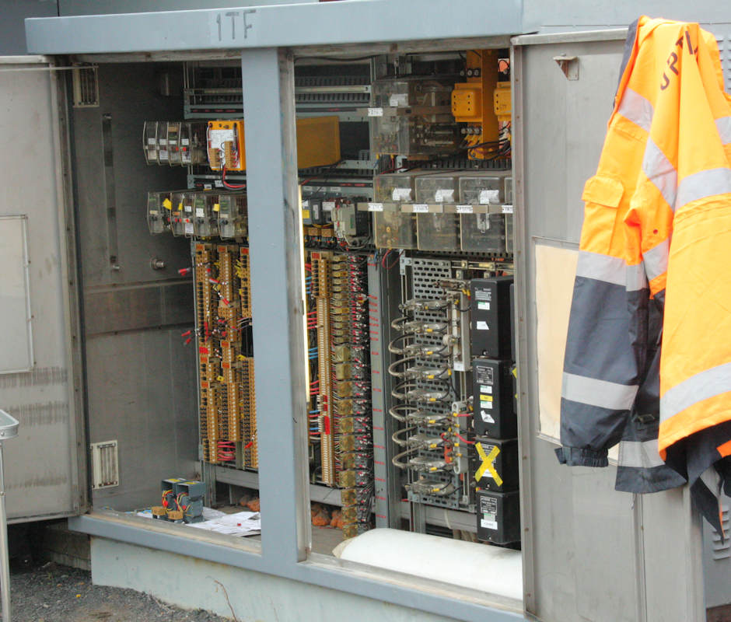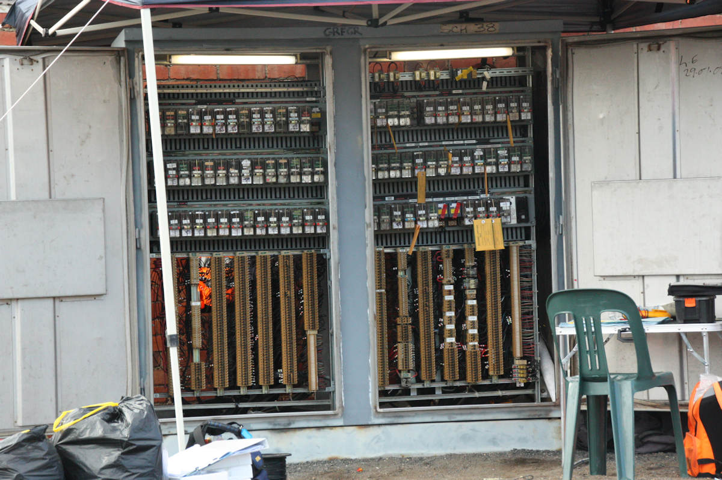As noted in the ‘Signalling Alterations’ section, the signalling associated with the tramway level crossing at Glenhuntly was altered commencing on 26 June 2017. Completion of the work dragged out until Thursday, 30 June. While this was unfortunate for commuters, it did allow an opportunity to see the inside of the normally locked signalling cabinets. (Above) There is no relay room at Glenhuntly. Instead, the interlocking is located in this equipment cabinet on the Down platform. This photo shows that the cabinet is completely filled with BR930 style relays in three rows. The lower half of the cabinet is used for cable termination. (Below) The adjacent equipment cabinet 1TF appears to be primarily used for track circuits. Five AC vane track relays, packaged as large plug in relays, can be seen at the top on the right side of this cabinet. These AC track circuits are immediately adjacent to the tramway crossing. The large boxes under the vane relays (one with a tape cross) are CSEE audio frequency track circuits for the platform tracks. More BR930 relays are on the left hand side of the cabinet, again with the cable termination below.

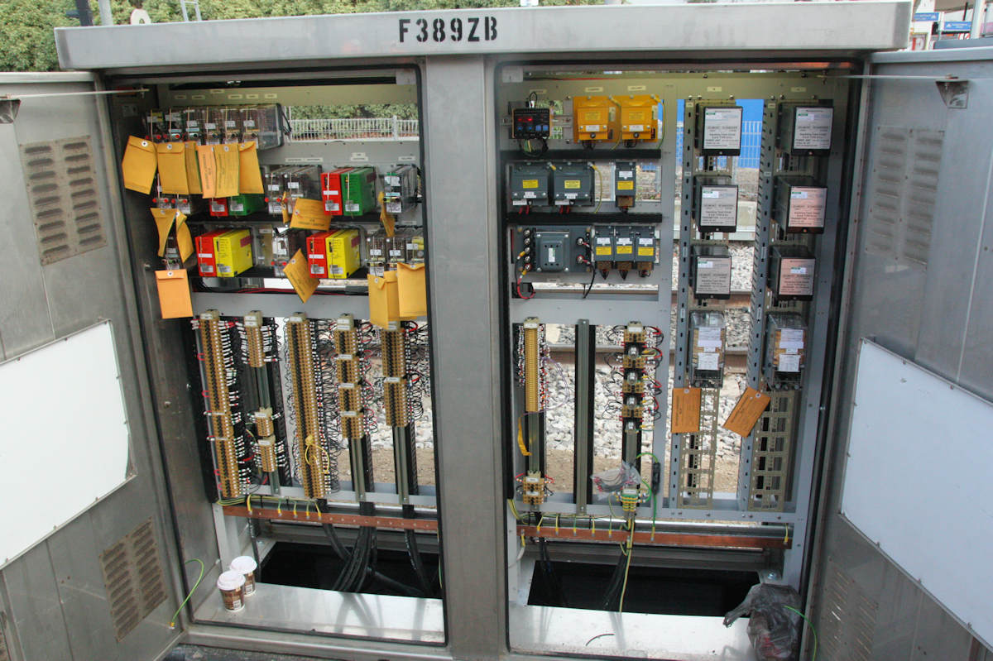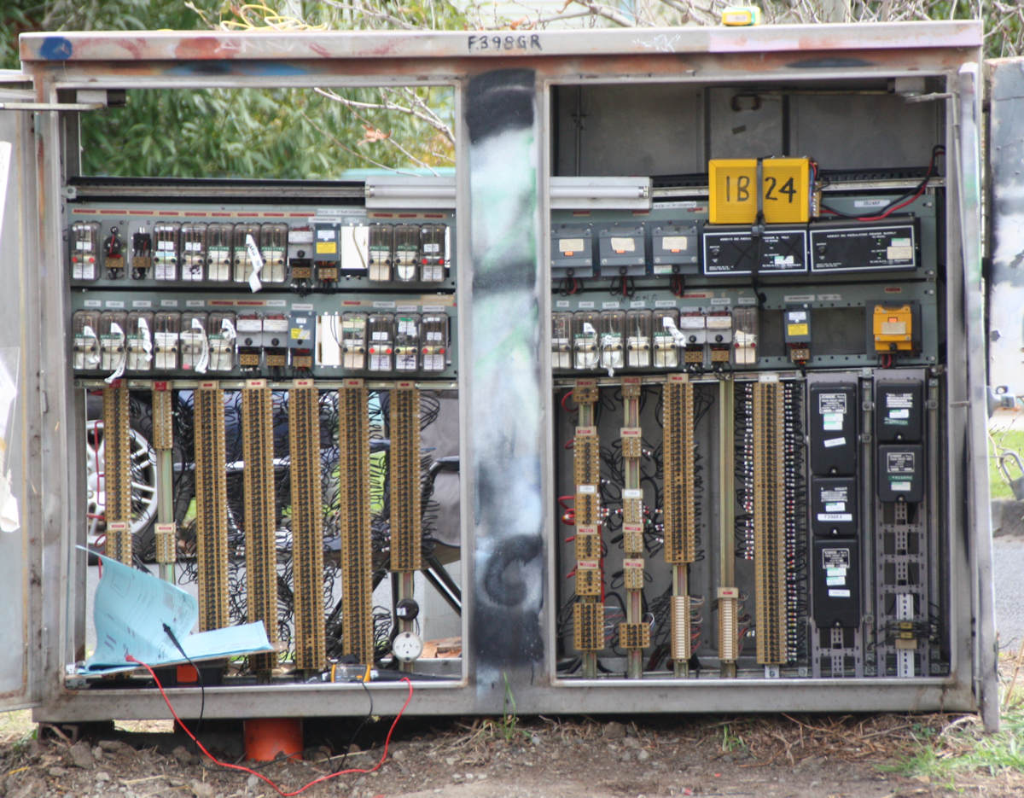(Above) Location F398GR is located on the Down side of Glenhuntly platform. The left hand portion of the location contains power supplies and track circuit equipment (the CSEE receivers and transmitters are, again, obvious). The right hand portion contains more BR930 relays controlling the adjacent signals. (Below) The new Location F389ZB was added as part of the work and, conveniently for photos, is located right next to the platform access. Working from right to left, the first two columns are Jeumont-Schneider track circuits which appear to have replaced the CSEE audio frequency track circuits in the Centre and Up platforms. The group of boxes at the top left of the right hand opening are mostly transformers. The left hand portion of the cabinet contains a mixture of BR930 relays and the TPWS modules. Again, cable terminations are at the bottom, and the cables can be seen going down from the risers. The two coffee cups have no signalling function, apart from keeping the commissioning technicians functioning.

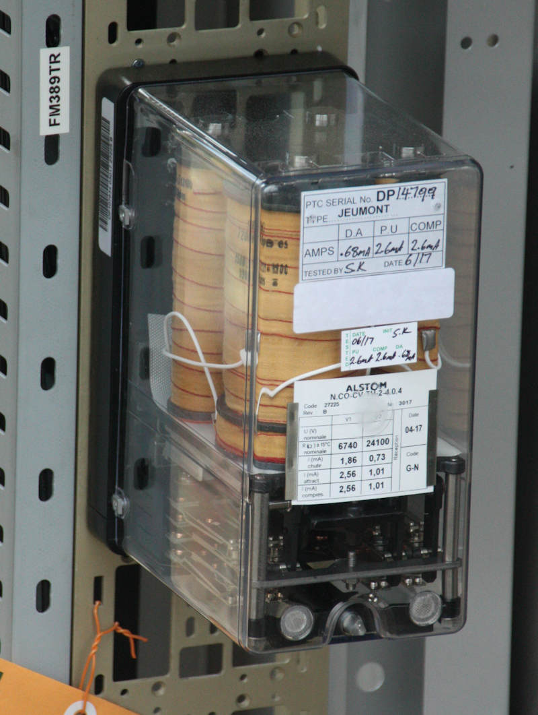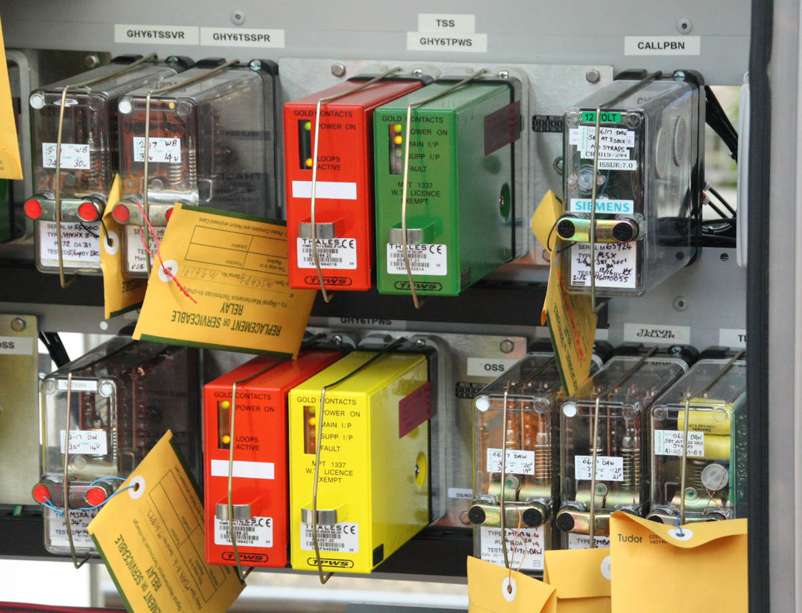(Above) Details of the TPWS control modules in F389ZB. These are both associated with the adjacent Up Home GHY6. The upper pair is for the TSS (Train Stop Sensor) TPWS at the signal, and the lower pair for the OSS (Over Speed Sensor) approaching the signal. In each pair, the left hand (red) box is the Signalling Interface Module (SIM) which interfaces to the signalling system, monitors the health of the TPWS, and manages the power supply. The right hand box generates the signal for track mounted antennas. The green box in the top row is a Train Stop Module – Normal Direction. In the lower row, the yellow box is a Overspeed Sensor Module – Normal direction. These colours are standard across manufacturers. Note that all these modules use a standard BR930 size case and fit into standard BR930 plugboards. The envelopes wired to the relays contain the relay cards. These are attached to each new or replacement relay. The commissioning technician fills in the card and it is sent to the Metro Infrastructure Asset Manager to keep a record of all relays in service. (Left) This is a new Jeumont-Schneider track relay for track circuit FM389.

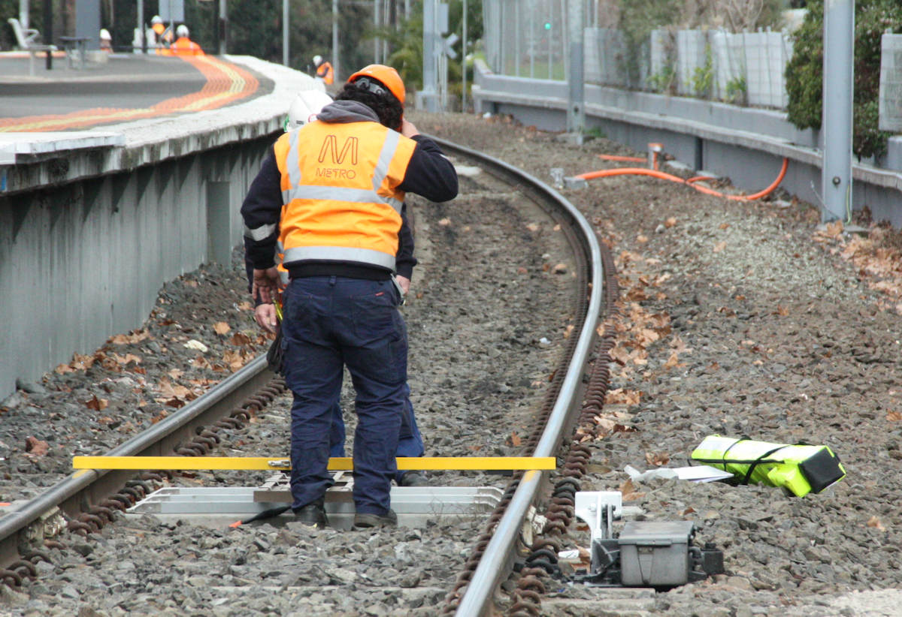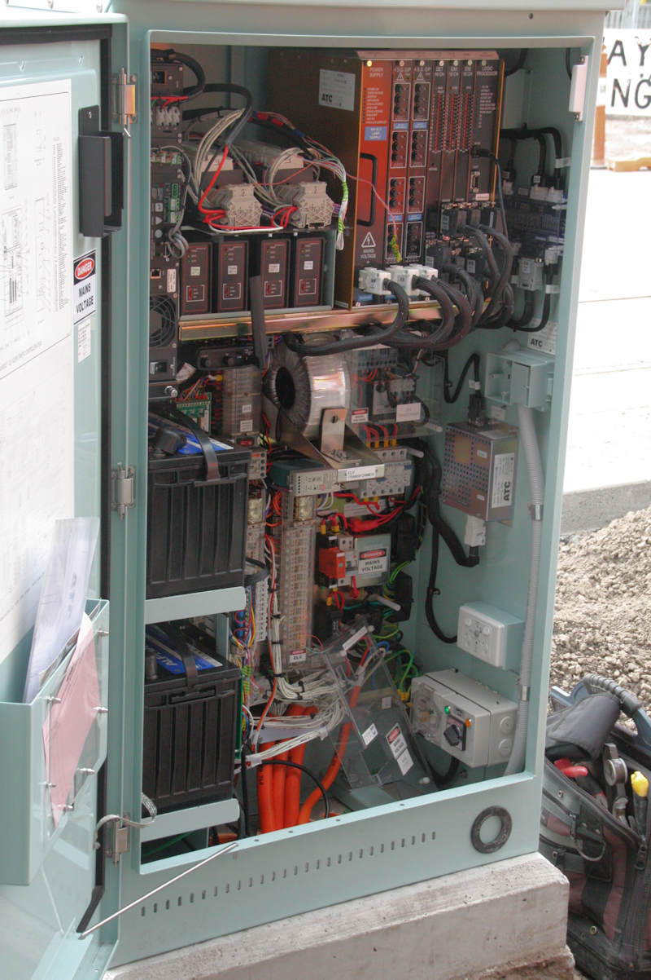(Left) The traffic light controller offers an interesting comparison with similar computer based railway signalling. This is located on the footpath on the south side of Glenhuntly Road west of the level crossing. In some ways, it is similar to a modern computer based railway signalling equipment case, but it is far more packed with equipment as ground area is far more restricted on a footpath. This controller is manufactured by ATC (Aldridge Traffic Controllers) and is an ELV ICUPS Traffic Controller ATSC4. The rack at the top right is the computerised controller. The cards are (from the right) the logic processor, two 16 channel external interface modules (e.g. pedestrian calls and railway inputs), a 16 channel vehicle detector module, two 4 signal group output modules, and the controller power supply. The four smaller boxes to the left of the controller are tram detectors. On the extreme left hand side of the box at the top is the UPS power supply with two large lead acid batteries below this. The equipment in the centre and lower right are power supply transformers and cable termination. The UPS is designed to allow operation of the traffic lights for up to 4 hours without mains power supply. (Below) Testing the strength of the signal of the TPWS (TSS) antenna at Home GHY2

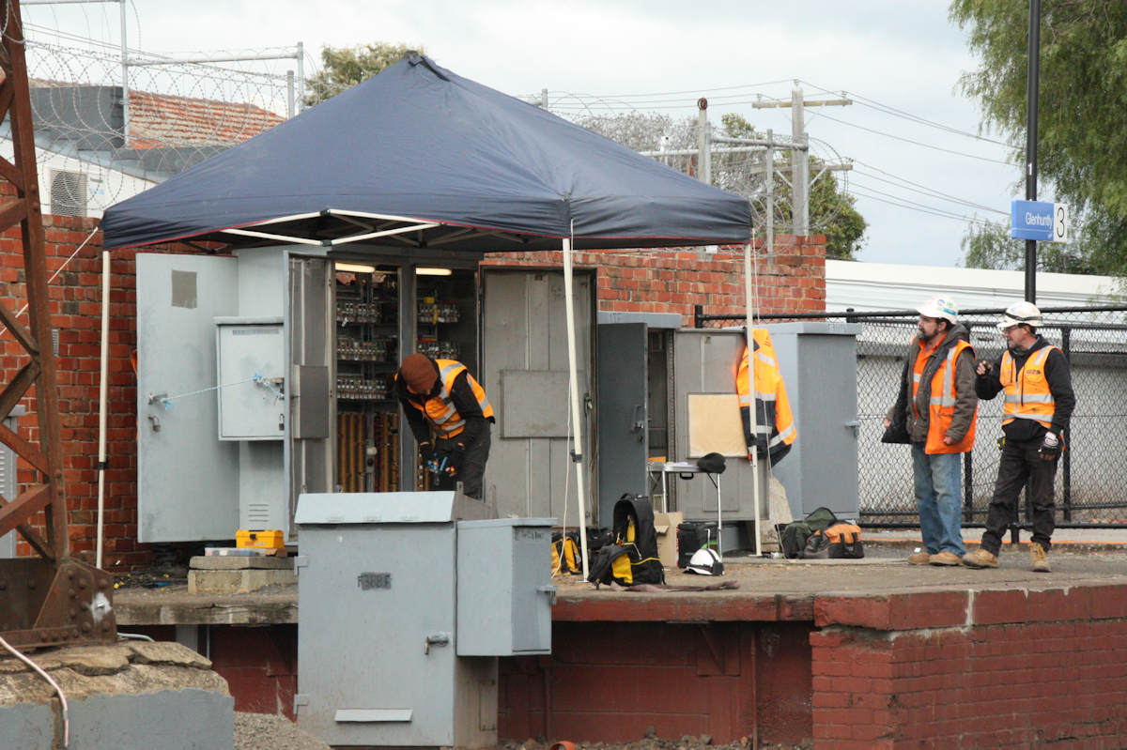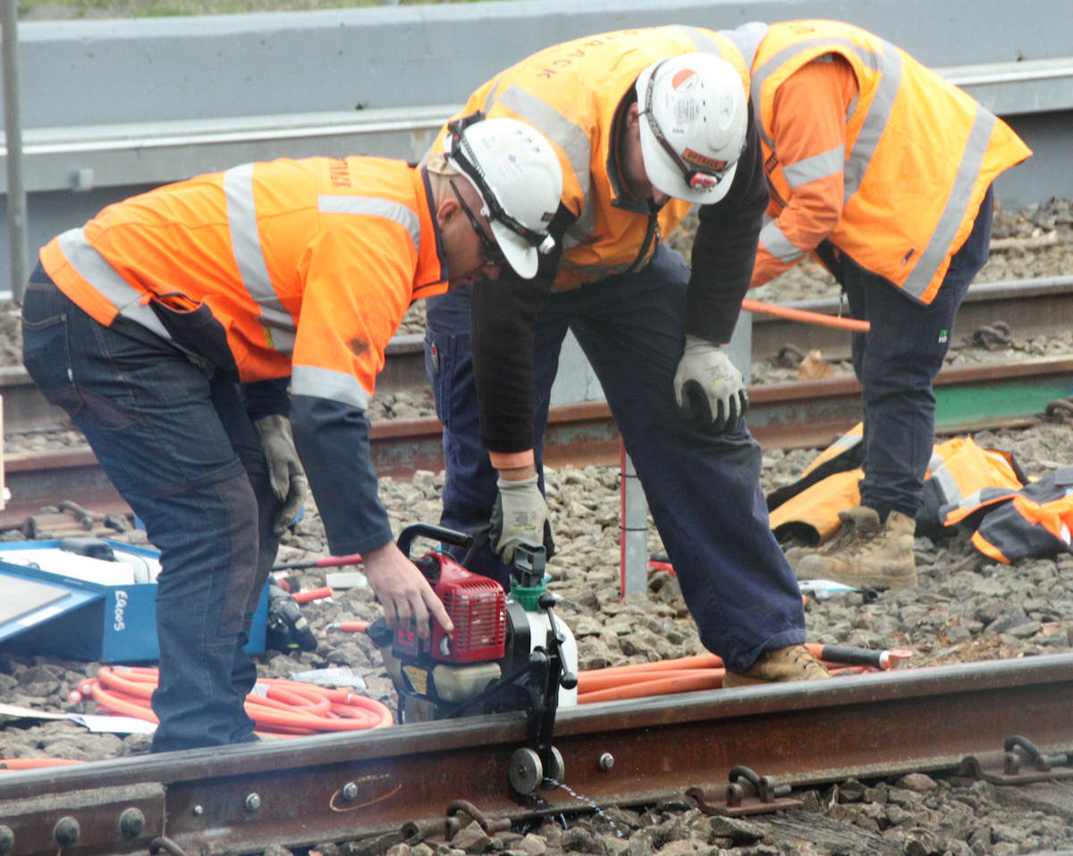(Above) Drilling a hole for connecting the wires from impedance bonds to the rails. Modern compact petrol motors have taken the labour out of this formerly slow and backbreaking work. Well drilled holes are important – clean holes ensure electrical connectivity between the rails and the wire remains good over time, and poorly drilled holes could cause the rails to fail due to fatigue cracking. (Below) Testing the alterations to the interlocking shows the major disadvantage of not providing a relay room. Shelter for the testing teams was provided by this canopy. While it did not rain during the commissioning, it was bitterly cold, especially during the night. I overheard one tech trying to claim that the EBA covered heated coats.

# Collision at Newport, 29 July 1872

Yet another regrettable incident on the Victorian Railways occurred on 27 July 1872. The incident, and its aftermath, illustrates a number of practices of the early Victorian Railways.

The Argus of 29 July 1872 (p5) reported that

The 10 minutes past 8 passenger train from Melbourne to Williamstown ran into a goods train at the Williamstown Junction [Newport] on Saturday morning. There were but a very few passengers in the former train, and of them Mrs. Lloyd, greengrocer, of Williamstown, who was looking out of a window at the time of the collision, and who received a flesh wound on the forehead, was the only one who was externally injured. The others were "only shaken.” […] The driver, Steele, and the other officials on the train, as well as those of the goods train, also escaped without any external injury. No harm was done to the engine or carriages of the passenger train, but the van and one truck of the goods train were seriously damaged. It seems that the goods train, which left Melbourne for Williamstown before the passenger train, was stopped a little on the Melbourne side of the Williamstown Junction station while some shunting was done and it was left standing on the down line that is to say, the line on which the down passenger trains to Williamstown run. In fact altogether, no collision could have been expected with greater certainty, or have been arranged for with more precision by the railway officials most experienced in such matters in any part of the globe. Just at the place where the collision occurred there is a sharp curve; at the time it occurred there was a drizzling rain; and the precaution of stationing a person behind the goods train to signal the passenger train, which left Melbourne, as usual, at 10 minutes post 8 o'clock that morning, was not taken, though the rules prescribe that it should have been. The result was, that the passenger train which, fortunately, was only going just the at the rate of about 10 miles an hour, ran into the rear of the goods train, and did the damage mentioned. We learn that the Stationmaster at Williamstown Junction has been suspended, pending an inquiry into the collision.

The Age of 29 July 1872 (p3) reported that

An accident took place on the Victorian railways last Saturday morning under circumstances which demand very strict inquiry. At eight o'clock the goods train, consisting of an engine, several trucks, and a van, left Melbourne for Williamstown as usual, and stopped at the Williamstown Junction, in order that the engine might do some shunting work which was required there. The engine was uncoupled, and went for a hundred yards or more up a siding, the train being left on the line. At ten minutes past eight a passenger train left Melbourne for Williamstown, on the same line. On approaching the Williamstown Junction the driver of the passenger train saw the goods train on the line before him, but not until it was too late for him to pull up, there being a thick drizzle of rain at the time. The consequence was that the engine of the passenger train ran into the van which was at the end of the other, and completely smashed it, injuring one of the trucks as well. Two lady passengers in the train received severe contusions on the head, the worst injured being a Mrs. Lloyd ; but both of them were able to walk away after a little attention. The question of who is to blame in this unfortunate matter will receive immediate attention, and it is expected that a board of inquiry will be appointed to-day by the Commissioner. Mr. Mathieson, the traffic manager, went down immediately after his arrival at the office, and examined all the employes concerned. Stephens, the stationmaster at Williamstown Junction, says he sent M'Leish, his porter, down to the driver of the engine which had left the goods train, telling him to return immediately; and M'Leish, we believe, affirms that he gave the driver this order; but the driver denies it, and further affirms that, had the order been given, it would have been too late, Dewsnap, the man at the semaphore, is another party who will be called up to give evidence ; but, so far, he appears to have done his duty. The question for the consideration of the board is whether Stephens ought not to have taken obvious measures which would have prevented the possibility of a collision. Had he troubled himself to walk down the line, and give the danger signal with his arms to the train which he knew to be approaching, he might readily have stopped it. Pending further inquiry, Stephens has been suspended.

A board of inquiry was instituted. This board consisted of Mr Templeton, a police magistrate. (chairman), Mr Henry P. Bance, an Inspector in the Post and Telegraph Department, and Mr Chaloner Greville, chief clerk in the Customs Department. None of the board appeared to have any railway experience. This appears to have been a reflection of the civil service disciplinary procedures where the members of a board came from other branches of the civil service. The inquiry seemed to be reasonably thorough, and even carried out tests on how fast the passenger train could brake.

The Argus of 13 September 1872 (p5) reported that

The collision which occurred on the 27th July last at the Williamstown Junction Railway Station, has at length been dealt with. The delay is principally accounted for by the fact that the board of inquiry reported not only upon the circumstances under which the collision occurred, but upon a supposed want of harmony between two branches of the Railway department. The one report consequently rendered several other reports necessary. First, the report deals with Steele, the driver of the passenger train which ran into the goods train. The question the board had to determine was whether the driver approached the semaphore, which was " at danger," at such rate of speed that he had not his train in thorough command when coming up to the station. They were clearly of opinion from the evidence that the driver had not sufficient; command over the train, especially as the semaphore was at danger. The result was that he came up to the spot where the goods train was standing on the down line waiting until some shunting was executed. On the other band, the evidence showed that the stationmaster did not take sufficient precautions. He was in his office when the goods train was standing at the platform. Though he knew the passenger train was following the goods train in 15 minutes or loss, he did not take care that whatever shunting was required should be done under his own superintendence; nor did he put the goods train upon the Geelong line, so that there might be a clear road for the passenger train. He merely gave some sort of orders to the porter who was there, and went back to his office. According to the evidence he ought to have sent a man up the line with a signal to warn the approaching train; but he evidently took things too easily. The Commissioner fined the station-master (Mr. Stephens) £16, and Steele, the driver, £10. The report next dealt with an apparent want of harmony between the traffic and locomotive branches in reference to the time of starting trains. This branch of the inquiry seemed to have been suggested by a statement made by the locomotive superintendent. Reports were obtained from the head of the two branches mentioned. The locomotive superintendent stated that they must have misunderstood him, because he did not wish to convey any such idea, and harmony had always prevailed. The board then called attention to the fact that a distance semaphore was recommended for this place two years ago, but somehow none had ever been erected. The Commissioner has ordered the erection of a semaphore. The action taken by the Commissioner has been confirmed by the Executive Council.

A special meeting of the Locomotive Enginedriver’s and Firemen's Association, held at the James Watt Hotel, Spencer street, resolved that Steel had been ‘very harshly treated’. It was alleged that the rule of the railway service, requiring a goods train to be either fifteen minutes ahead of a passenger train or to be shunted, was not observed. The precaution of sending a man to warn any following train was not observed when the goods train stopped at the junction, and it was impossible for Steele, the driver of the passenger train, to see the goods train before him, owing to the curve and the trees in an intervening paddock. A circular protesting against the findings was addressed to various MPs and was signed by Steel and other drivers. This caused the report of the incident to be laid on the table of the Legislative Assembly, and was duly reported by The Argus and The Age.

The Argus of 20 November 1872 (p7) reported:

IMPORTANT RAILWAY INQUIRY

The report of the board appointed to inquire into the circumstances attending the railway collision which occurred at the Williamstown Junction on the 27th July last was presented to the Legislative Assembly yesterday. It has already been stated that upon the finding of the board, Steele, the engine driver, was fined £10, and Stephens, the stationmaster, £16.

The board, which consisted of Mr W. Templeton (chairman), Mr H P. Bance, and Mr Chaloner Greville, state that the absence of proper distance semaphores was the principal cause of the collision, and add- We are surprised to learn that although a memorandura was addressed by the traffic manager to the Commissioner of Railways so far back as the 3rd of June 1870, pointing out that all or nearly all the previous collisions had occurred from the want of distant semaphores, and urging their erection at the Williamstown Junction, among other stations, no notice whatever seems to have been taken of the matter. We think it right, also, to call attention to the evidence of Mr Meikle, the locomotive Superintendent, where he states that a practice has lately grown np on the part of the traffic branch of altering the time-tables without consultation or communication with his branch of the department; and that the alteration in the running time has in some cases been carried so far as (to use his own words).' not to leave a sufficient margin for safety.' It also transpired that although the traffic office thought it had notified the time of starting of the goods train at 8 a.m. from Melbourne, it had only notified the time of leaving Williamstown; and although perhaps, as the manager observes, the officials concerned ought to have known that an engine must have been despatched from Melbourne to bring the half-past 8 train from Williams town, and that a number of trucks were always attached to the outgoing engine, we do not think that such an event as the departure of a goods train shortly before a passenger one should have been left to the chance knowledge or want of knowledge of those who were to look out for it. In point of fact, on this occasion Smith, the guard of the passenger train, states in his evidence that 'he had no idea there was anything in front of him that morning,' and so satisfied was he on that point that when he saw the 'goods' standing at the junction, he thought it was the passenger train from Williamstown. Moreover, it appears to us that the traffic office, having recognised the necessity of advising all guards of the time of leaving Williamstown, was equally bound to notify the time of leaving Melbourne; and we consider the officers of the traffic branch to blame for not having done so. The whole of the evidence, indeed, seems to indicate the want of a good understanding and a cordial co-operation between the traffic and locomotive branches, and suggests the idea that this result must have been brought about by their having been left too much to themselves, and without the guidance and control of some superior authority ; and wo very much fear that unless they are kept more in hand, and made to work better together, the end will be the occurrence of a catastrophe which will be found on inquiry to have been occasioned in a great measure by the differences of opinion and independent modes of action of the two branches of the department."

The Age of 23 November 1872 (p6) reported

THE WILLI AM8TOWN RAILWAY COLLISION

The report of the board appointed to inquire into the cause of the recent railway collision at Williamstown Junction, together with the evidence taken, was laid before Parliament on Tuesday by the Commissioner of Railways, in return to a motion by Mr. Longmore. The papers were of a most voluminous character, the report of the board alone occupying eleven pages of closely-written foolscap. The final paragraph is to the following effect: — The whole of the evidence, indeed, seems to indicate the want of a good understanding and a cordial co-operation between the traffic and locomotive branches, and suggests the idea that this result must have been brought about by their having been left too much to themselves and without the guidance and control of some superior authority, and we very much fear that unless they are kept more in hand and made to work better together, the end will be the occurrence of a catastrophe which will be found on inquiry to have been occasioned in a great measure by the differences of opinion and independent modes of action of these two branches of the department.

In consequence of the report of the board, the Commissioner of Railways issued the following: —

After a careful perusal of the report of the board and the evidence, together with memo, from the traffic manager, and also from the locomotive overseer, the Commissioner is of opinion that Steele, the driver of the passenger train, is much to blame for coming into the station in the way he did under the circumstances. His evidence is not consistent with that given by the guard of his own train, and inconsistent also with the experiment subsequently caused to be made by the board. Had Steele been keeping a proper look out, and had his train been more under control in approaching the station, with the danger signal displayed, there is no doubt but that he could have pulled up in a much shorter distance, and have prevented a collision. The station-master, Stephens, is also to blame. There appears to have been an utter absence of discretion in permitting inferior officers to superintend important work for which he was mainly responsible. The Commissioner quite concurs in the remarks of the board on Stephens's conduct and duty. The observations made by the board un the want of co-operation between the traffic and locomotive branches are satisfactorily answered by the traffic manager and locomotive overseer respectively. The absence of a distant semaphore is no doubt to be regretted; that will, however, be attended to at once, and one will be erected without delay. Steele, the engine-driver, will be fined £10, and Stephens, the station-master, £15, inclusive of the time of suspension.— D. Gillies.

Steele was not at all satisfied with this decision, and accordingly prepared a lengthy statement, criticising the report of the board, to which he induced several other engine-drivers to append their signatures, and then had it printed for circulation among members of Parliament. This came to the knowledge of the Commissioner of Railways, who issued the following memorandum : —

The Commissioner has had brought under his notice a statement, dated 12th int., signed by B. J. F. Steele, and vouched for, so far as it makes reference to the rules and practice of railways, by the drivers on the Victorian railways whose names are in the margin. The statement referred to has been printed and distributed among members of Parliament, and is an appeal by driver Steele from the decision of a board of inquiry appointed by the Governor-in-Council, and the decision of the Minister at the head of the department, confirmed by the Governor-in-Council. If driver Steele had ceased to be in the public service he would of course be entitled to appeal to members of Parliament or to the public for whatever redress he thought proper to seek, but being in the public service he is subject to its rules. The Commissioner therefore takes this opportunity to place on record his disapproval of the coarse adapted by driver Steele in seeking a reversal of the decision of the Minister and the Governor-in-Council, by an appeal to individual members of Parliament. Such a course is altogether subversive of any proper discipline in the public service, and of the regulations of the service, and cannot therefore be permitted to pass unnoticed. The statement itself is full of impertinences and insinuations against driver Steele's superior officers, and contains several gross misstatements. If the Commissioner were of opinion that the statement was wholly the production of driver Steele, he would feel it his duty to recommend his dismissal from the public service; but as the Commissioner prefers to think that the statement was drawn up by some person not in the service, the punishment which will be inflicted on Steele will be a fine of £2 for having signed and circulated the statement referred to. The locomotive superintendent will inform the other drivers whose names are attached to the statement of this minute, and add that while the Commissioner will not in this case inflict any punishment on them for having added their names, as that was probably done without much consideration, it must be understood that insubordination of the kind if repeated will not be similarly passed over. - D. Gillies.

This incident could well have been the cause of a more general provision of distant signals on the Victorian Railways, particularly where the view of the Home signal was obscured. The active nature of the union is also to be noted, even at this early date.